**Project Development phase**

**Project Development delivery of sprint 2**

|  |  |
| --- | --- |
| Team ID | PNT2022TMID50833 |
| Project name | Plasma donorapplication |

**Architecture:**

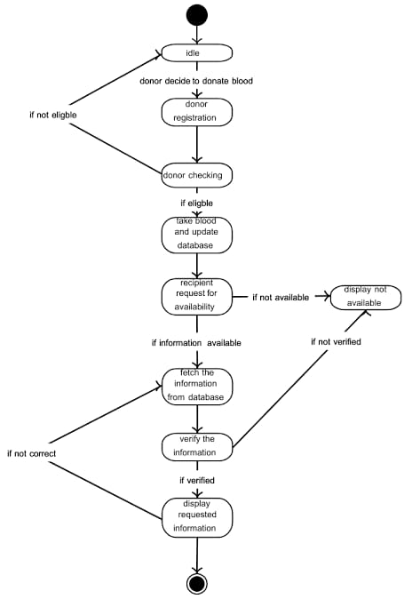

**Program/coding:**

<target name="-pre-init">

<!-- Empty placeholder for easier customization. -->

<!-- You can override this target in the ../build.xml file. -->

</target>

<target depends="-pre-init" name="-init-private">

<property file="nbproject/private/config.properties"/>

<property file="nbproject/private/configs/${config}.properties"/>

<property file="nbproject/private/private.properties"/>

</target>

<target depends="-pre-init,-init-private" name="-init-user">

<property file="${user.properties.file}"/>

<!-- The two properties below are usually overridden -->

<!-- by the active platform. Just a fallback. -->

<property name="default.javac.source" value="1.6"/>

<property name="default.javac.target" value="1.6"/>

</target>

<target depends="-pre-init,-init-private,-init-user" name="-init-project">

<property file="nbproject/configs/${config}.properties"/>

<property file="nbproject/project.properties"/>

</target>

<target depends="-pre-init,-init-private,-init-user,-init-project,-init-macrodef-property" name="-do-init">

<property name="platform.java" value="${java.home}/bin/java"/>

<available file="${manifest.file}" property="manifest.available"/>

<condition property="splashscreen.available">

<and>

<not>

<equals arg1="${application.splash}" arg2="" trim="true"/>

</not>

<available file="${application.splash}"/>

</and>

</condition>

<condition property="main.class.available">

<and>

</condition>

<condition property="profile.available">

<and>

<isset property="javac.profile"/>

<length length="0" string="${javac.profile}" when="greater"/>

<matches pattern="((1\.[89])|9)(\..*)?" string="${javac.source}"/>

</and>

</condition>

**CLOUD COMPUTING:**

cloud computing is the delivery of computing services—including servers, storage, databases, networking, software, analytics, and intelligence—over the Internet (“the cloud”) to offer faster innovation, flexible resources, and economies of scale. You typically pay only for cloud services you use, helping lower your operating costs, run your infrastructure more efficiently and scale as your business needs change.